Class 10 Assignment – Trigonometry – Mark: / 38 NAME:
- Find the unknown lengths in the following right-angled triangles. (8 marks)
8 cm
$x$ cm
65º

$x$ m
12.5 m
75º

- Find the unknown angle in the following triangles (4 marks)
1.9 m
1.2 m
$θ$º

40 mm
$θ$º
65 mm

- Jason is on a cargo ship offshore. He observes a lighthouse on a cliff and estimates that the angle of elevation from him to the top of the light house is $15$º. If the light house is 55 metres above the ship’s level, determine how far the ship is from the base of the cliff. (3 marks)

- A hiker decides to climb a mountain and measure the direct distance from the base of the mountain to the top. After climbing the mountain he calculates that the direct distance from the base to the top is 2.8 km. It is known that the mountain is 1.2 km tall. What is the angle of elevation from the base of the mountain to the top? (2 marks)

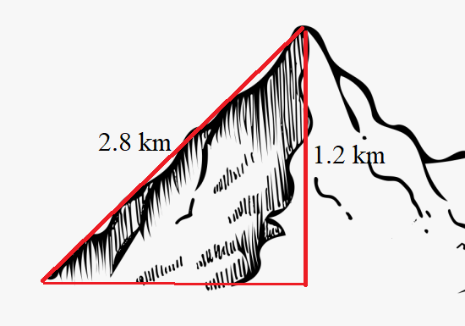

  - State the three-figure bearings of each of the following points: A, B, C from $O$ (3 marks)
B
N
55º
65º
30º
C
A
W
E
S

$$O$$

  - Give the three-figure bearing of $O$ from C. (2 marks)

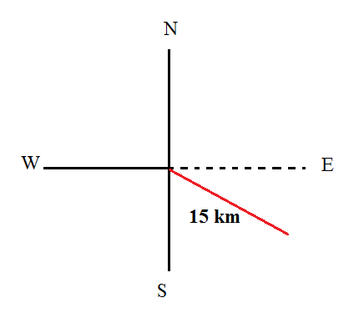
- A ship left port and sailed for 15 km on a bearing of 145º.
  - Determine how far east the ship has travelled. (2 marks)
145º

  - Determine how far south the ship has travelled. (2 marks)

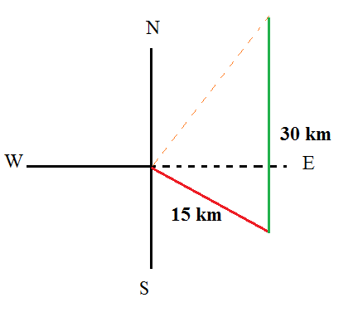
The ship then travelled 30 km north.

  - BONUS Determine the direct distance from the ship to the starting point, $O$ (1 marks)

- Find the unknown length in the following triangle using the sine rule (3 marks)

- Find the unknown (acute)angle in the following triangle. (3 marks)

$θ$º
3.5 m
108º

2.7 m

- Find the unknown length in the following triangle. (2 marks)
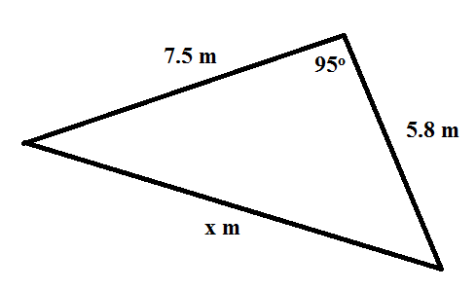

- Find the unknown angle in the following triangle. (2 marks)
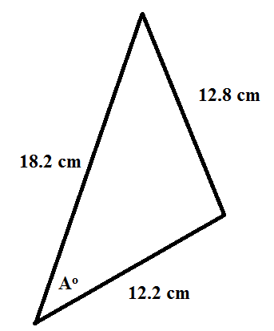

- Find the area of the following triangle (2 marks):
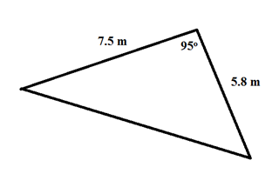

- (BONUS) Determine the unknown angle, $θ$, in the following triangle, given that $θ$ is obtuse. (2 marks)

